A Project Report On
SkillRoute AI: Real-Time Adaptive AI Interview Mentor for Personalized
Communication and Interview Skill Development
Submitted to
JAWAHARLAL NEHRU TECHNOLOGICAL UNIVERSITY ANANTHAPUR, ANANTHAPURAMU
In Partial Fulfillment of the Requirements for the Award of the Degree of

BACHELOR OF TECHNOLOGY
In

COMPUTER SCIENCE AND TECHNOLOGY
Submitted By

R BALAJI - (22691A2828)

Under the Guidance of
Dr K Dinesh
Assoc. Professor and Head
DEPARTMENT OF COMPUTER SCIENCE AND TECHNOLOGY


MADANAPALLE INSTITUTE OF TECHNOLOGY & SCIENCE (UGC – AUTONOMOUS)
(Affiliated to JNTUA, Ananthapuramu) Accredited by NAAC, Approved by AICTE, New Delhi
AN ISO 21001:2018 Certified Institution
P. B. No: 14, Angallu, Madanapalle – 517325 2022-2026



DEPARTMENT OF COMPUTER SCIENCE AND TECHNOLOGY

BONAFIDE CERTIFICATE

This is to certify that the Project Work and Internship (20CST703) work entitled “SkillRoute AI: Real-Time Adaptive AI Interview Mentor for Personalized Communication and Interview Skill Development” is a bonafide work carried out by

R BALAJI - (22691A2828)

Submitted in partial fulfillment of the requirements for the award of degree Bachelor of Technology in the stream of Computer Science and Technology in Madanapalle Institute of Technology & Science, Madanapalle, affiliated to Jawaharlal Nehru Technological University Ananthapur, Ananthapuramu during the academic year 2025-2026.

Guide Head of the Department
Dr. K. Dinesh Dr. K. Dinesh
Assoc. Professor and Head Assoc. Professor and Head Department of CST Department of CST
Submitted for the university examinations held on

Internal Examiner External Examiner
Date: Date:

ACKNOWLEDGEMENT

We would like to express our sincere gratitude to the Management of Madanapalle Institute of Technology & Science for providing exceptional infrastructure and laboratory facilities that were instrumental in enabling us to successfully complete our project. The excellent resources and support provided by the institution played a vital role in helping us achieve our academic goals.
We express our sincere gratitude to Dr. P. Ramanathan, M.E., Ph.D., Principal, for his invaluable guidance and unwavering support that enabled us to successfully complete our project at Madanapalle Institute of Technology & Science, Madanapalle.
We are deeply grateful to Dr. K. Dinesh, M.Tech., Ph.D., Associate Professor and Head, Department of CST, for his steadfast support and tireless efforts that contributed to the successful completion of our project.
We are immensely grateful to Mr. Abdul Jaleel D, M.E., (Ph.D.), Assistant Professor, Project Coordinator, Department of CST for his invaluable guidance, encouragement, and support that enabled us to successfully complete this project.
We would like to express our profound gratitude to our guide, Mr. Abdul Jaleel D, M.E., (Ph.D.), Assistant Professor, Department of CST, for his invaluable guidance and unwavering encouragement that played a pivotal role in the successful completion of our project. His expertise, in sights, and mentorship were crucial in navigating the intricacies of the project and achieving our objectives.
We express our sincere thanks to Mr. V. Naveen, M.E., (Ph.D.), Assistant Professor, Internship Coordinator, Department of CST for his tremendous support for the successful completion of the Project.
We would also like to express our gratitude to the other faculty members of the Department of CST and our parents for their invaluable help and support during our project work.

INTERNSHIP CERTIFICATE
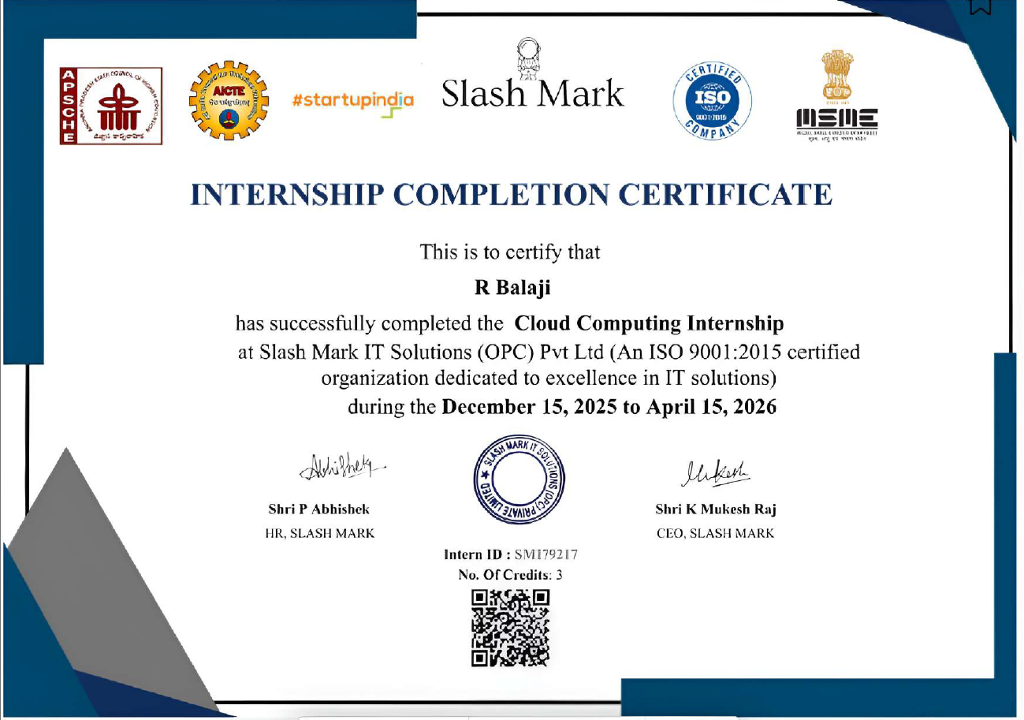


DEPARTMENT OF COMPUTER SCIENCE AND TECHNOLOGY
Plagiarism Verification Certificate
This is to certify that the B. Tech Project Work and Internship (20CST703) work report titled, “SkillRoute AI: Real-Time Adaptive AI Interview Mentor for Personalized Communication and Interview Skill Development” submitted by R BALAJI - (22691A2828) has been
evaluated using Anti- Plagiarism Software, Turnitin and based on the analysis report generated by the software, the report’s similarity index is found to be 5%.

HOD-CST

DECLARATION
We hereby declare that the results embodied in this Project Work and Internship (20CST703) work “SkillRoute AI: Real-Time Adaptive AI Interview Mentor for Personalized Communication and Interview Skill Development” by us under the guidance of Dr. K. Dinesh, Assoc. Professor and Head, Department of CST in partial fulfillment of the award of Bachelor of Technology in Computer Science and Technology from Jawaharlal Nehru Technological University Anantapur, Ananthapuramu and we have not submitted the same to any other University/institute for award of any other degree.

Date:
Place:

PROJECT ASSOCIATE

R BALAJI

I certify that the above statement made by the students is correct to the best of my knowledge.

Date: Guide
Dr. K. Dinesh Assoc. Professor and Head Department of CST

ABSTRACT

Interview preparation is often limited by static practice methods that do not reflect real interview conditions. Many learners face difficulty not because of a lack of knowledge, but due to challenges in communication, confidence, and real-time response handling. This creates a gap between academic learning and practical performance.
SkillRoute AI is developed to address this gap by providing an interactive platform that adapts its behavior based on user responses. The system conducts interview sessions where questions are generated dynamically, and each interaction is adjusted depending on how the user performs during the session.
User responses are processed in both audio and text formats. The system evaluates not only the content of the response but also delivery-related aspects such as response timing and hesitation patterns. Based on this evaluation, the system generates feedback that helps users understand their performance in a more practical way.
A key feature of the platform is its ability to modify the flow of the interview instead of following a fixed sequence. This allows each user to experience a unique session that closely resembles real interview scenarios. The overall design focuses on improving communication ability, confidence, and readiness through repeated interaction.
Keywords: AI-based Interview System, Adaptive Learning, Speech Analysis, Communication Skills, Personalized Training

TABLE OF CONTENTS

CHAPTER NO | TITLE | PAGE NO
 | ACKNOWLEDGEMENT | iii
 | DECLARATION | vi
 | ABSTRACT | vii
 | LIST OF FIGURES | xi
 | LIST OF TABLES | xii
 | LIST OF ABBREVATIONS | xiii
1 | INTRODUCTION | 1
 | 1.1 Overview | 2
 | 1.2 Motivation | 3
 | 1.3 Problem Definition | 4
 | 1.4 Proposed Solution | 5
 | 1.5 Objectives | 6
 | 1.6 Scope | 7
 | 1.7 Organization of Report | 8
2 | LITERATURE SURVEY | 9
 | 2.1 Introduction | 10
 | 2.2 AI-Based Interview Systems | 11
 | 2.3 Conversational AI | 12
 | 2.4 Speech Analysis Systems | 13
 | 2.5 Intelligent Tutoring Systems | 14

 | 2.6 Limitations | 15
 | 2.7 Research Gap | 16
3 | PROBLEM ANALYSIS | 17
 | 3.1 Introduction | 18
 | 3.2 Existing System | 19
 | 3.3 Limitations | 20
 | 3.4 Need for Proposed System | 21
 | 3.5 Proposed System Overview | 22
 | 3.6 Advantages of Proposed System | 23
 | 3.7 Feasibility Study | 24
4 | SYSTEM DESIGN | 25
 | 4.1 Introduction | 26
 | 4.2 System Architecture | 26
 | 4.2.1 User Interaction Layer | 26
 | 4.2.2 Processing and Intelligence Layer | 26
 | 4.3 System Workflow | 27
 | 4.4 Module Description | 27
 | 4.5 Data Flow Diagram | 29
 | 4.6 Algorithm Design | 29
 | 4.7 Design Considerations | 29
 | 4.8 Advantages of System Design | 30
 | 4.9 Detailed System Architecture Explanation | 30
 | 4.10 Conclusion | 32
5 | IMPLEMENTATION & RESULTS | 34
 | 5.1 Introduction | 34
 | 5.2 Development Environment | 34

 | 5.3. System Implementation | 35
 | 5.3.1 Frontend Implementation | 35
 | 5.3.2. Backend Implementation | 35
 | 5.3.3 AI Integration | 36
 | 5.4. Database Design | 36
 | 5.5. Results and Output | 37
 | 5.6 Screenshots | 37
 | 5.7 Advantages of Implementation | 38
 | 5.8 Limitations | 38
 | 5.9 Backend Implementation | 39
 | 5.10 Frontend Implementation and Architecture | 42
 | 5.11 Testing and Evaluation | 61
6 | CONCLUSION | 65
 | 6.1. Summary of the Project | 66
 | 6.2. Achievements | 66
 | 6.3 Key Contributions | 66
 | 6.4 Conclusion | 67
7 | FUTURE SCOPE | 68
 | 7.1. Introduction | 68
 | 7.2. Future Enhancements | 69
 | 7.3 Conclusion | 69
 | REFERENCES | 70

LIST OF FIGURES

FIGURE  NO. | NAME OF THE FIGURE | PAGE  NO.
4.1  4.2 | System Architecture  Data Flow Diagram | 29  30
5.1 | Dashboard UI | 37
5.2 | Interview Screen | 38
5.3 | Feedback Output of AI | 42

LIST OF TABLES

TABLE  NO. | NAME OF THE TABLE | PAGE  NO.
5.1  5.2 | Test Cases  Performance Metrices | 34  63

LIST OF ABBREVIATIONS
AI | Artificial Intelligence
NLP | Natural Language Processing
AWS | Amazon Web Services
API | Application Programming Interface
UI | User Interface
STT | Speech-to-Text
TTS | Text-to-Speech
DB | Database

